**RYAN SPORT CLUB**

**User Guide**

|  |  |  |
| --- | --- | --- |
| **Faculty** | **Miss Neelam Malik** | |
| **Batch** | **2209C1** | |
| **Group** | **B** | |
| **Serial No.** | **Enrollment Number** | **Student Name** |
| 1. | Student1418272 | MUHAMMAD HASEEB |
| 2. | Student1417834 | HAMZA SIDDIQUI |
| 3. | Student1414888 | MUHAMMAD SARIB |
| 4. | Student1414765 | MUHAMMAD SAIF ULLAH |

**Screenshots**

**Home page**

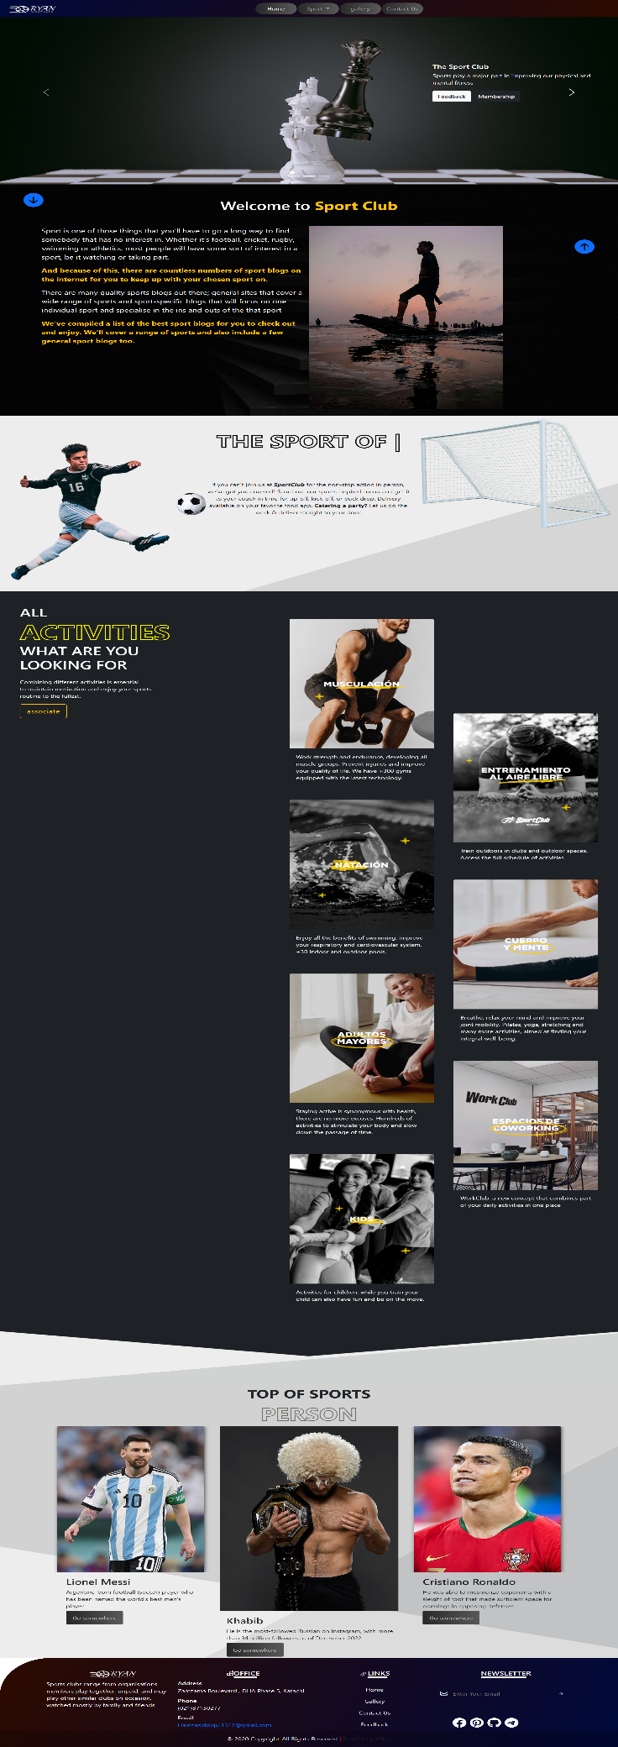

**Sports**

1. Indoor Sport
2. Outdoor Sport

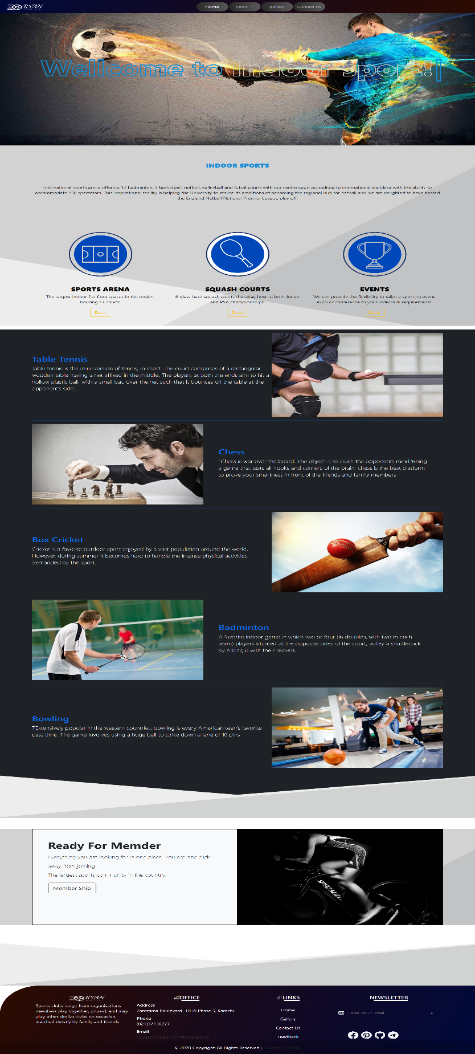**Indoor Sport**

**Outdoor Sport**

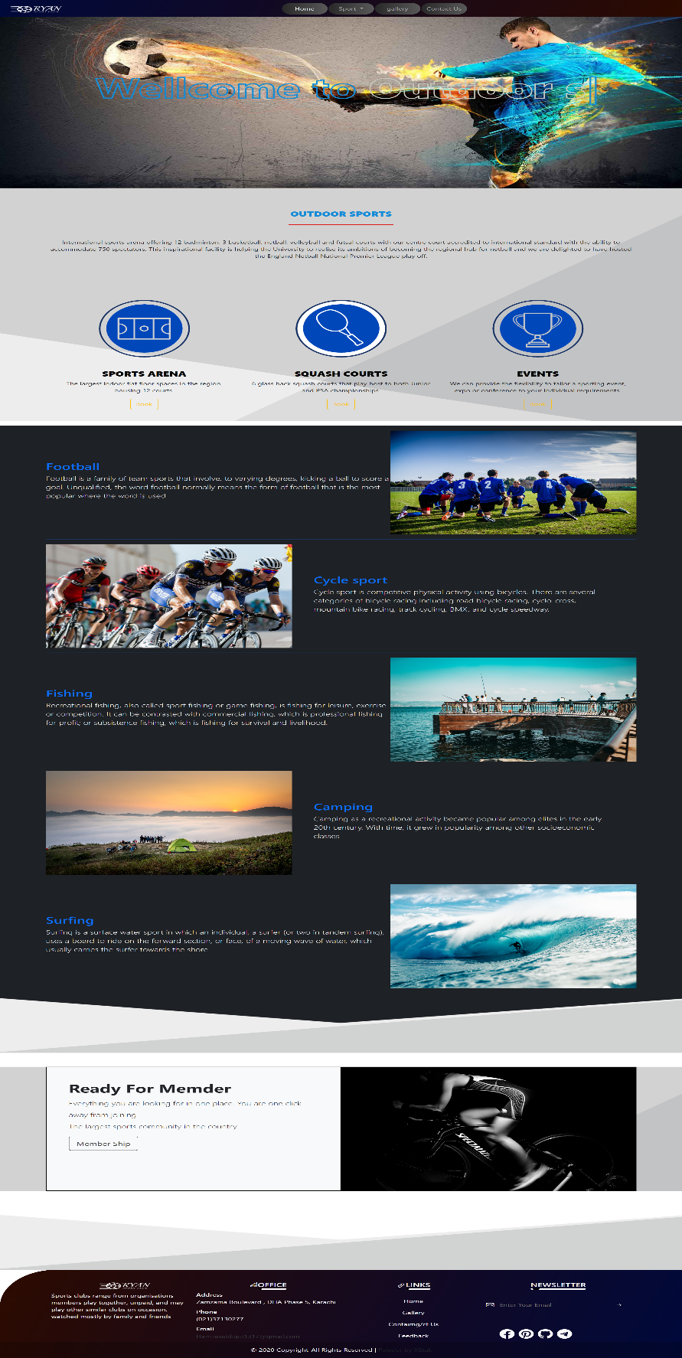

**Gallery**

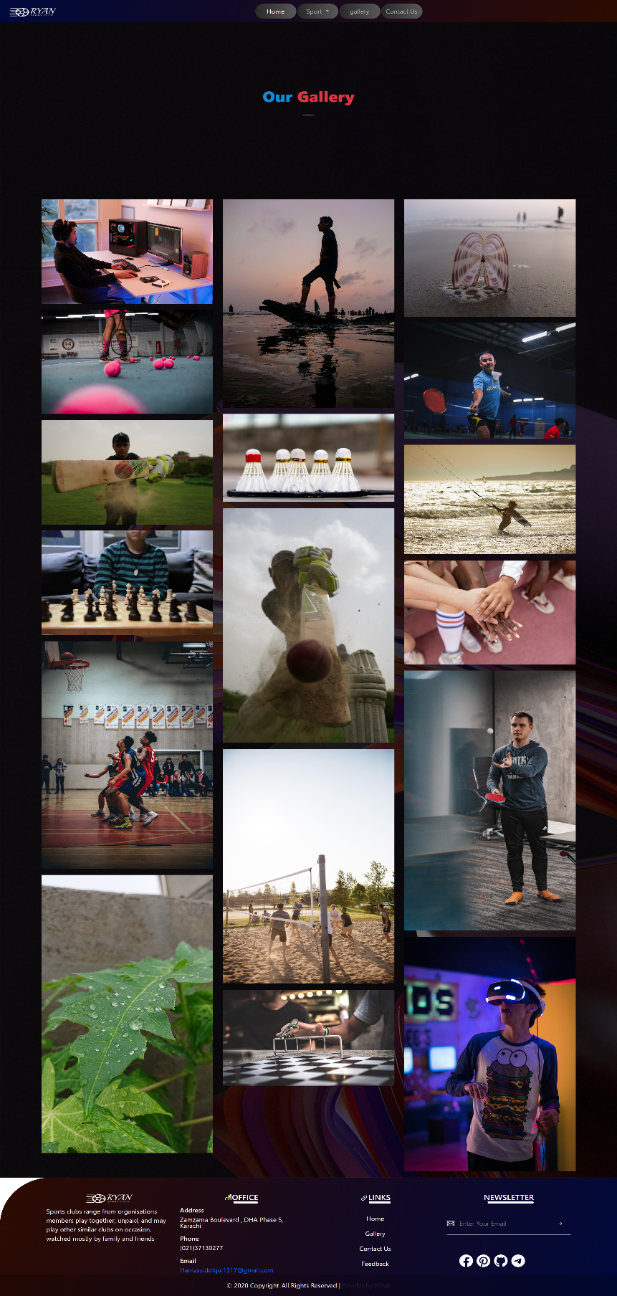

**Contact Us**

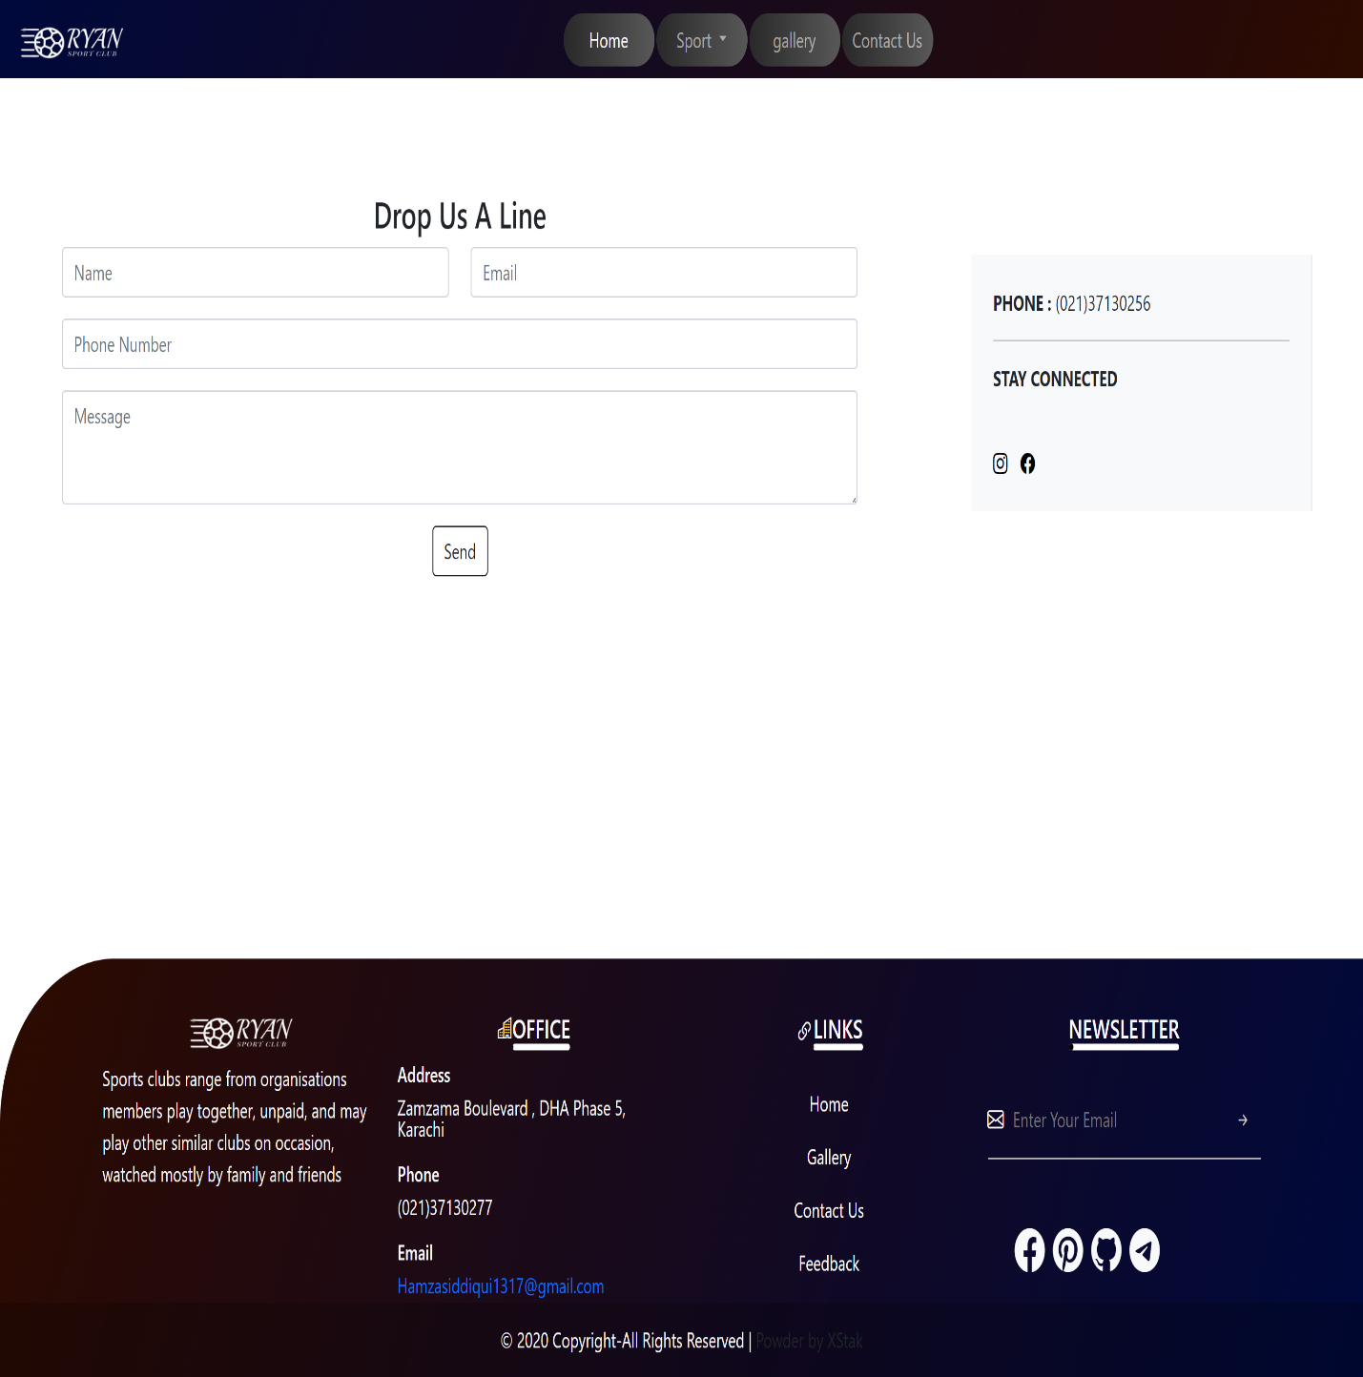

**Feedback**

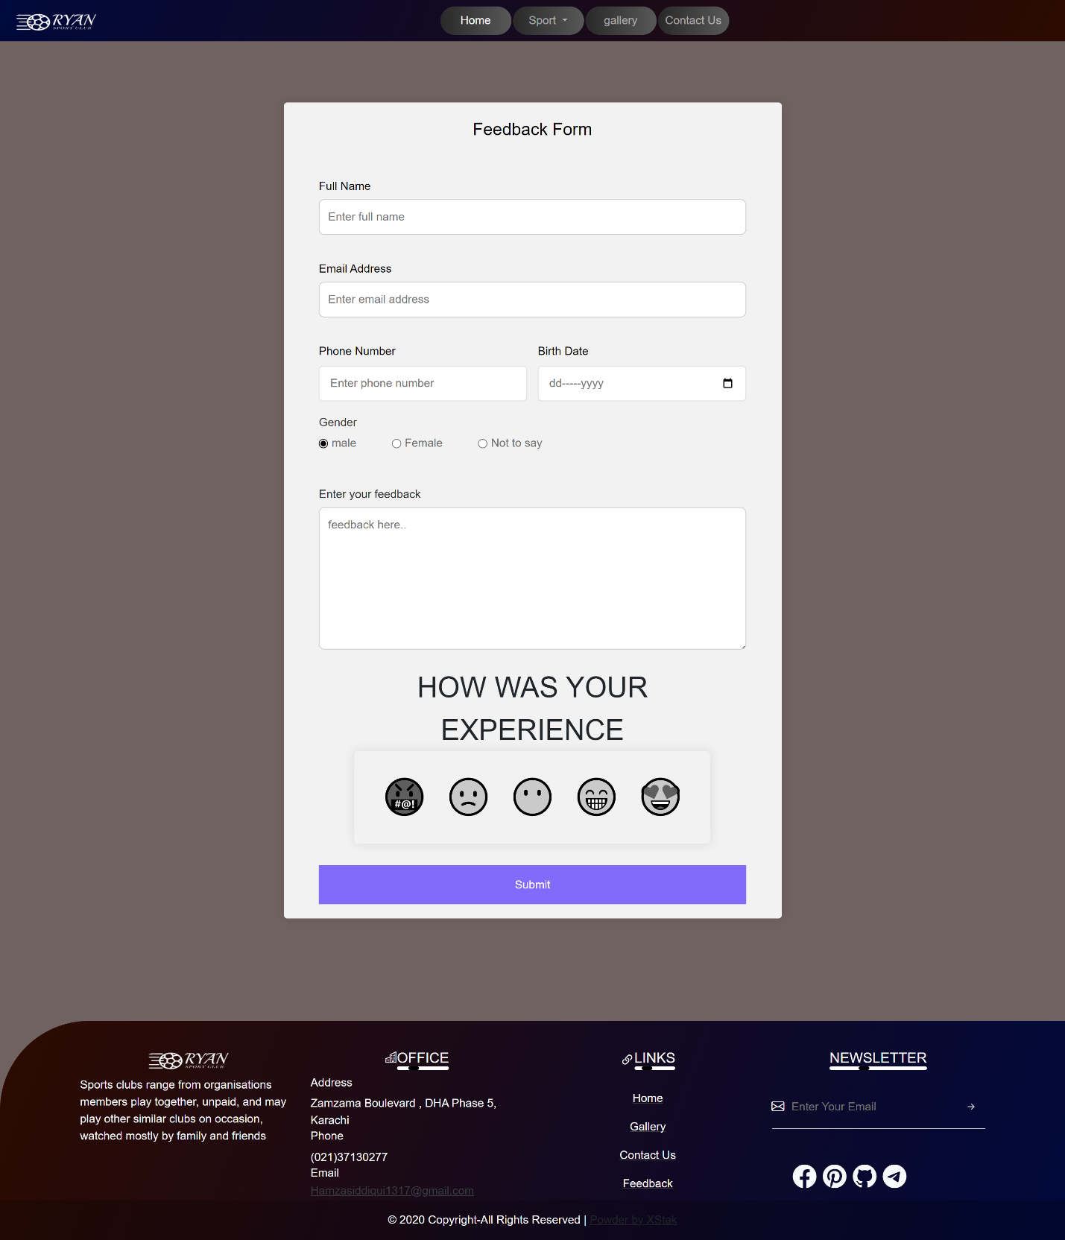

**Member Ship**

1. Monthly
2. Annual

**Monthly**

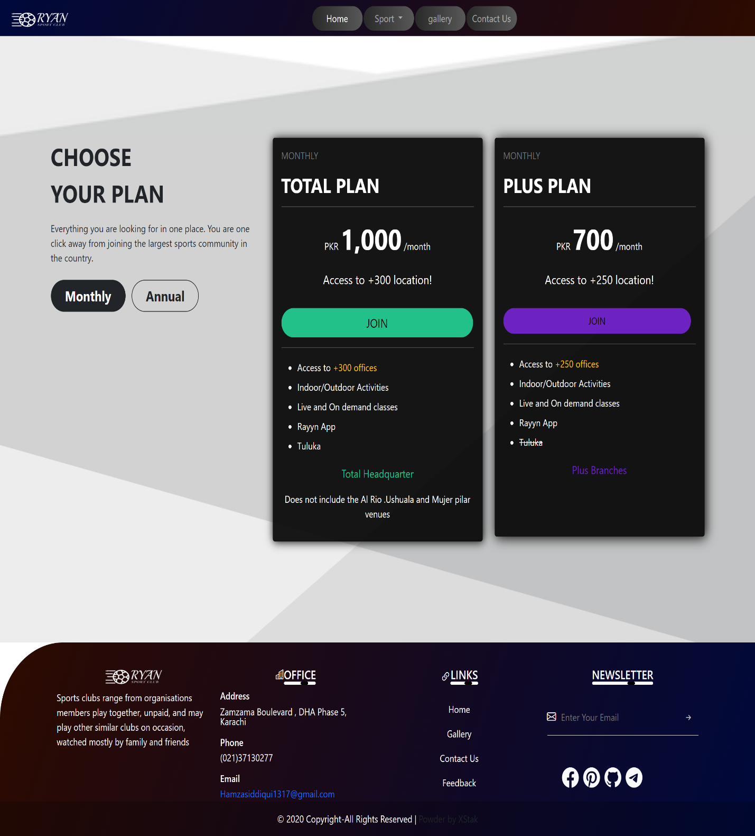

**Annual**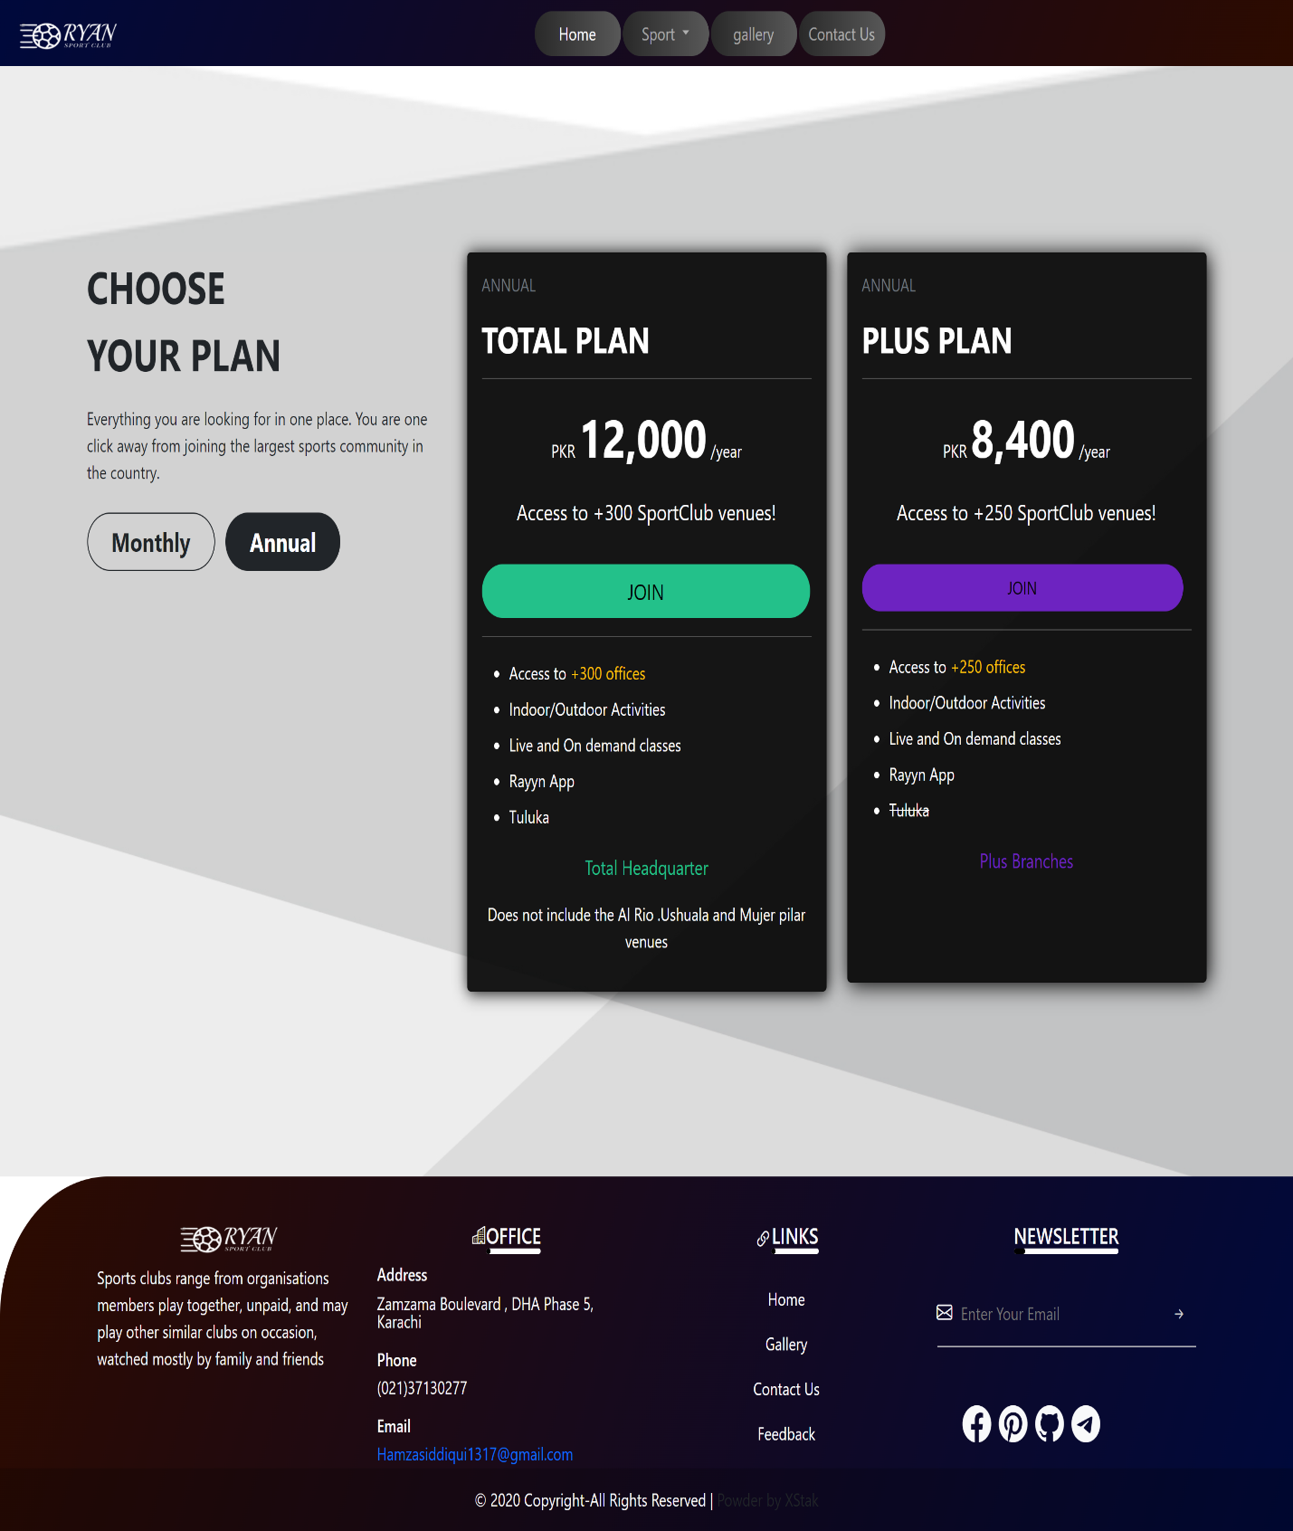

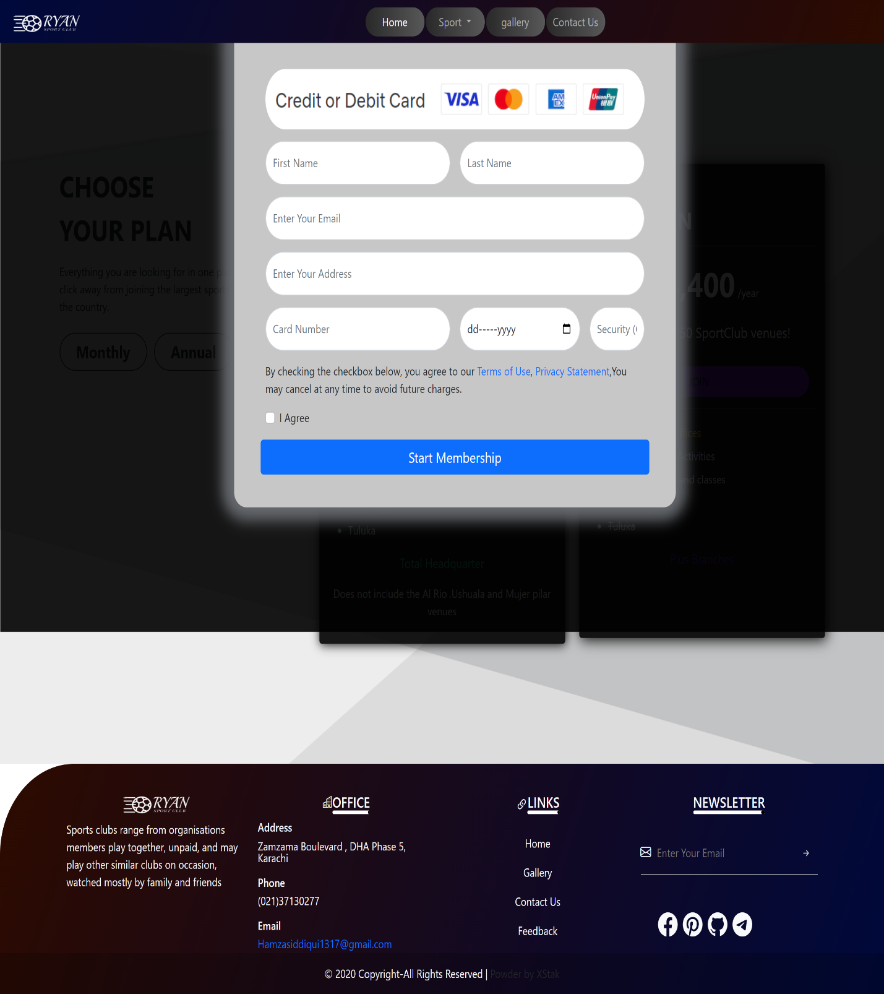

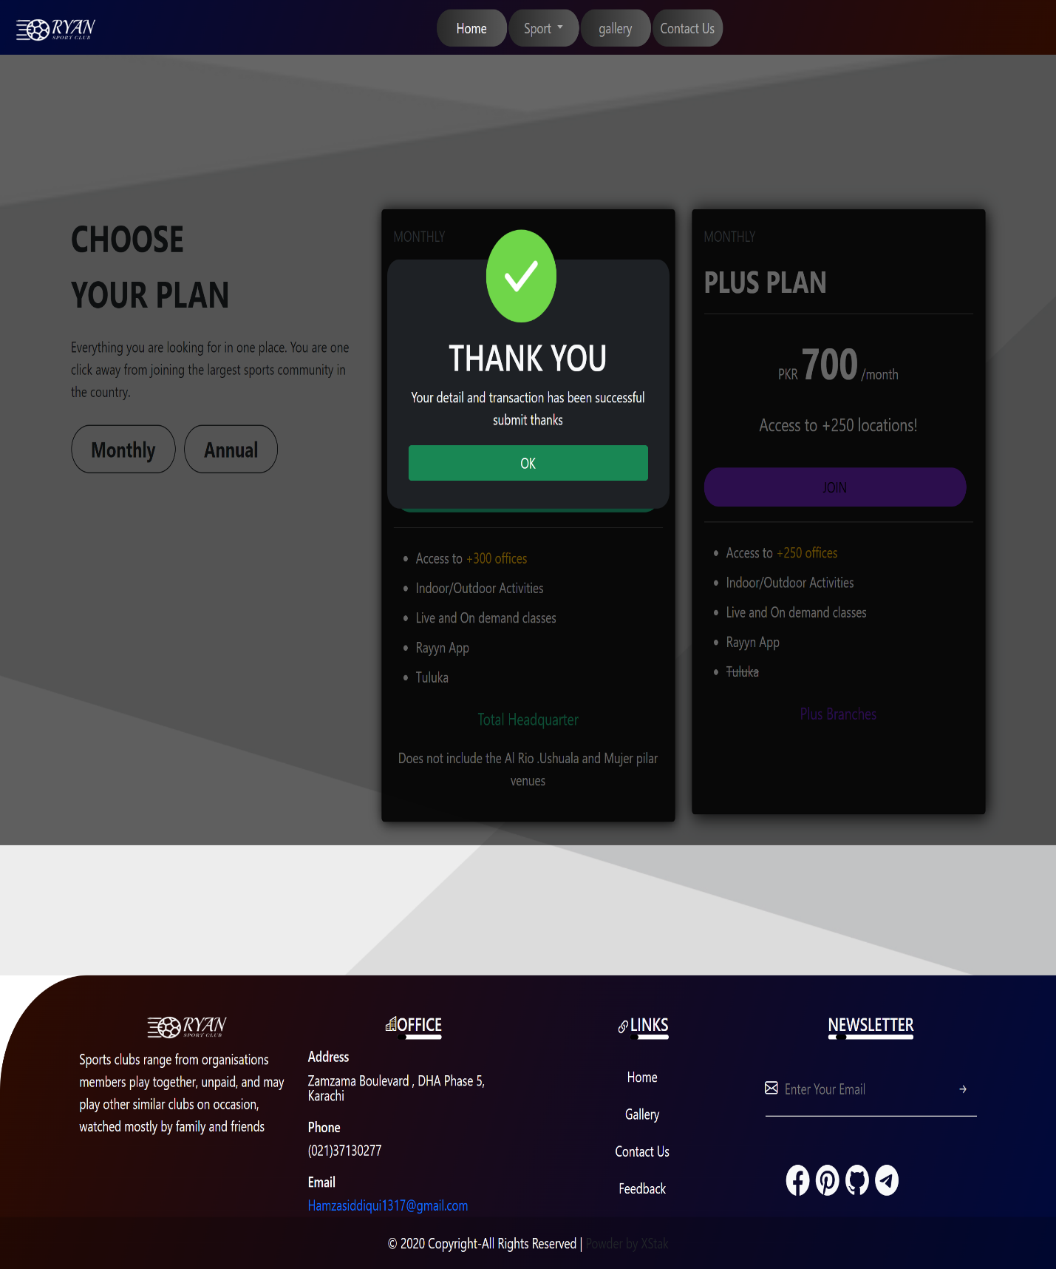

**TASK SHEET REVIEW 1**

|  |  |  |  |  |  |  |
| --- | --- | --- | --- | --- | --- | --- |
| Project Ref. No.: eP/Advertisement Portal Management System/01 | | Project  title | Date of Preparation of Activity Plan | | | |
| No | Task | RYYAN  SPORT CLUB | Actual | Actual | Team-mate | Status |
| Start Date | Days | Names |
| 1 | Navbar | 12/JAN/2023 | 1 | HAMZA SIDDIQUI | Complete |
| 2 | Main Body Navbar | 13/JAN/2023 | 1 | HAMZA SIDDIQUI | Complete |
| 3 | Footer | 15/JAN/2023 | 2 | HAMZA SIDDIQUI | Complete |
| 4 | **clone of Home page** | 17/JAN/2023 | 2 | HAMZA SIDDIQUI | Complete |
| 5 | Activity | 21/JAN/2023 | 4 | HAMZA SIDDIQUI | Complete |
| 6 | Indoor page | 24/JAN/2023 | 3 | HAMZA SIDDIQUI | Complete |
| 7 | Outdoor page | 26/JAN/2023 | 2 | HAMZA SIDDIQUI | Complete |
| 8 | Contact page | 28/JAN/2023 | 1 | HAMZA SIDDIQUI | Complete |

**TASK SHEET REVIEW 2**

|  |  |  |  |  |  |  |
| --- | --- | --- | --- | --- | --- | --- |
| Project Ref. No.: eP/Advertisement Portal Management System/01 | | Project title | Date of Preparation of Activity Plan | | | |
| No | Task | RYYAN  SPORT CLUB | Actual  Start Date | Actual  Days | Team-mate  Names | Status |
| 1 | Gallery | 30/JAN/23 | 2 | HAMZA SIDDIQUI | Complete |
| 2 | Member ship | 2/FAB/23 | 3 | HAMZA SIDDIQUI | Complete |
| 3 | Feedback | 4/FAB/23 | 2 | SARIB SALEEM | Complete |
| 4 | J query and JavaScript | 10/FAB/23 |  | HAMZA SIDDIQUI | Complete |